Week 7 – Activity Log
Activity 1 – Implement interface features
Table 1- Requirements identified previously
Requirement | User type | Task it supports | Notes
The website must clearly explain the coaching and mentoring services available. | Prospective client | Find out what services are offered | Helps new users understand the business quickly.
The website must make contact options easy to find from any page. | Prospective client | Contact or book a consultation | Reduces effort and uncertainty for users.
The website must provide clear information about coaches’ qualifications, experience, and testimonials. | Prospective client / Potential partner | Check credibility and trustworthiness | Supports trust and reassurance.
The website must allow clients to book or enquire about sessions online. | Prospective client / Returning client | Book or enrol on a session | Supports the company’s main service goal.
The website should provide wellbeing advice and resources that are easy to access. | Prospective client / Returning client | Access support and advice | Encourages engagement with the website.
The website must work effectively on mobile phones, tablets, and desktop devices. | All users | Browse and contact the business easily | Important because many users will use mobile devices.
The website must use clear navigation, readable text, and accessible colour contrast. | All users | Access information easily | Supports accessibility and inclusion.
The website should include information about what happens after making contact or booking. | Prospective client | Understand the next steps | Helps users feel confident before enquiring.
The website should provide partnership or referral information for organisations or professionals. | Potential partner / Referrer | Learn about collaboration opportunities | Supports future business growth.
The website should allow returning clients to quickly access booking or session information. | Returning client | Manage appointments and sessions | Improves convenience for existing clients.

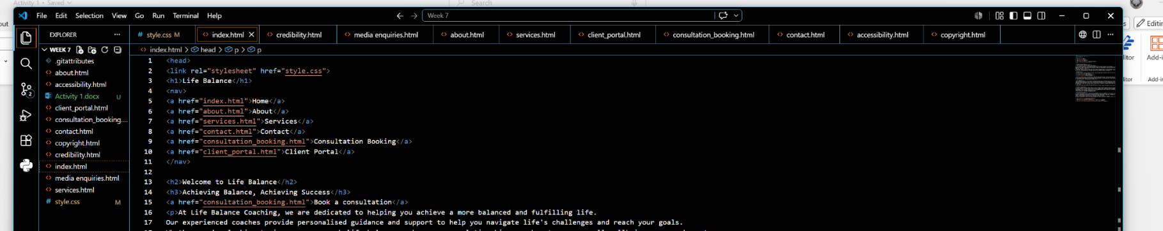
Figure 1 – Screenshot of my file/folder structure showing the project files I have created

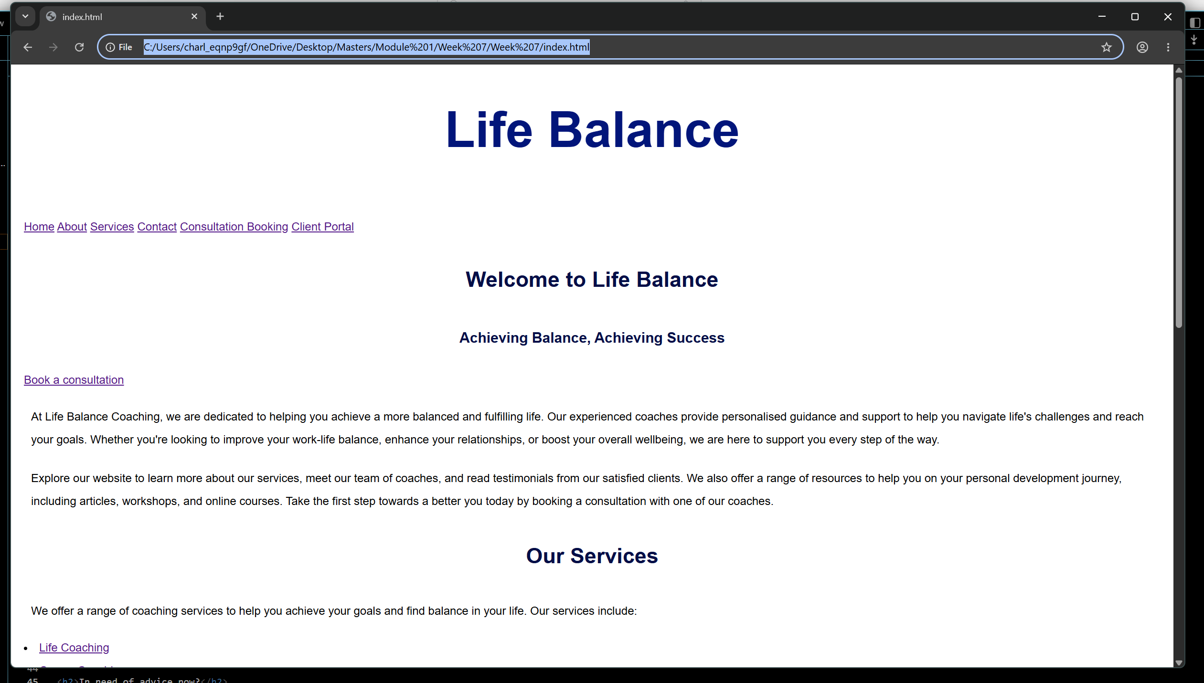
Figure 2 – Page 1 (index/home) working in the browser

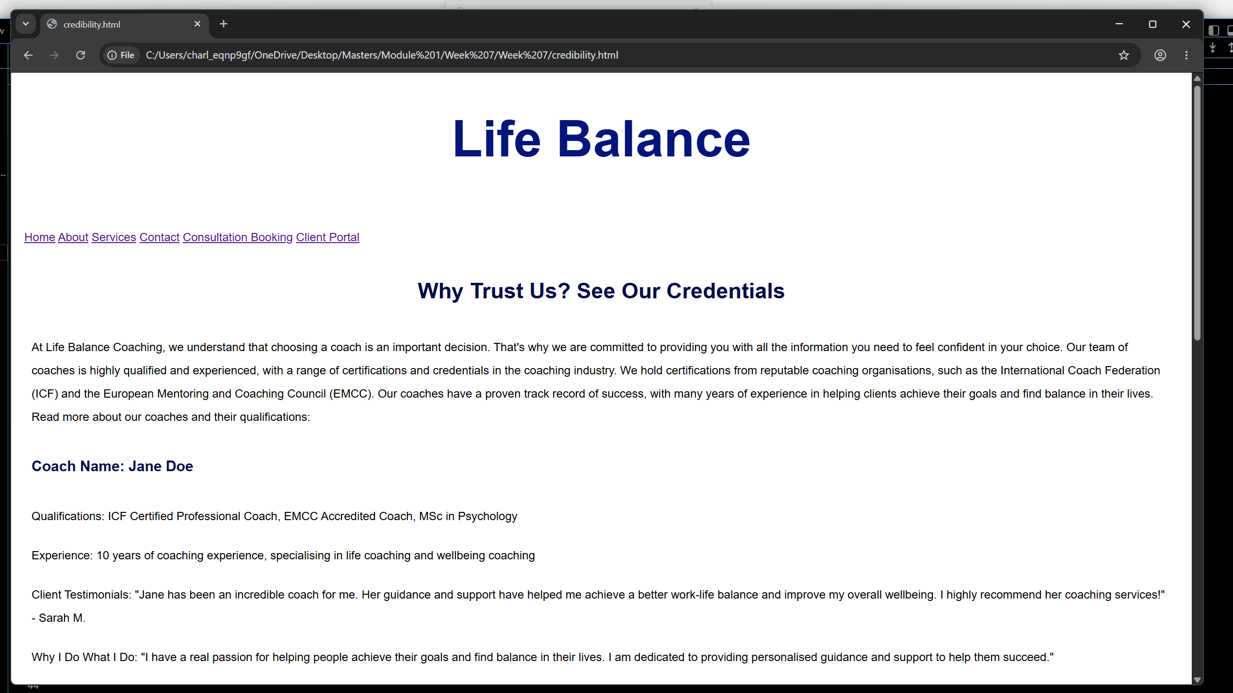
Figure 3 – Page 2 (credibility) working in the browser

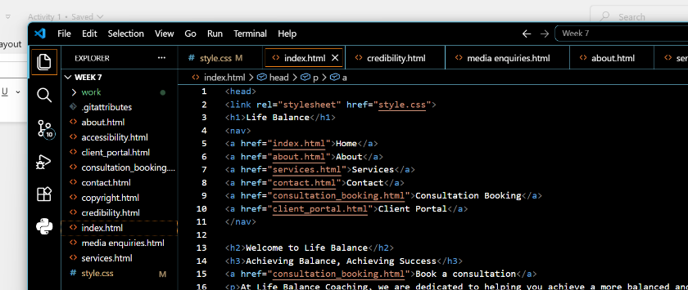
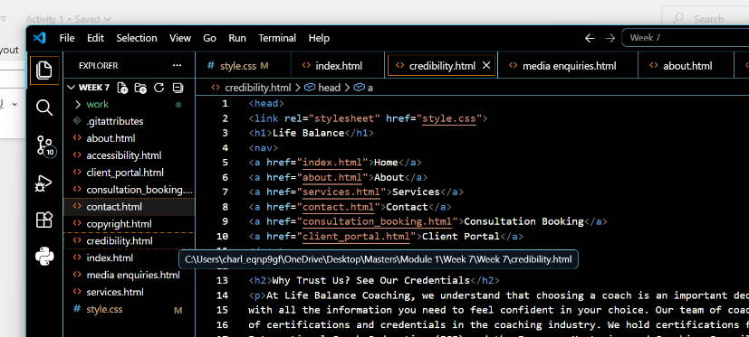
Figures 4 and 5 – Evidence showing the navigation works (nav visual HTML on both files)
What did I implement?
- Easy to follow file/folder structure
- Logical and consistent nav links on each page
- CSS media query for smaller screens
- Consistent typography throughout
Which requirement or user need does it address?
- The website must make contact options easy to find and follow from any page
- The website must provide clear information on coaches’ qualifications/experience
- Must allow new clients to book or enquire
- Must work effectively on mobile browsers, tablets and desktops
- Clear navigation
- Readable text
- The website should allow returning clients to quickly access booking or session information
What did I deliberately not implement yet (scope control) and why?
- The website should provide partnership or referral information for organisations or professionals.This will be added at a later date. I felt this was not an immediate requirement given that the website is new and the need to sign up new clients was a priority. I felt the credibility page of the website had a greater need as this would also go some way in showing potential partnerships how reliable and experienced Life Balance is. There is, however, a dedicated Media Enquiries contact form.

Activity 2 – Test and refine implementation
Checklist:
- Click every link and check they work
  - PASS. Every link on every page works
- Navigation is consistent between pages
  - PASS. Navigation bar and footer navigation consistent on every page
- Headings are in a sensible order
  - PASS. Headings are in a sensible order and relevant to the page
- Easy to scan
  - PASS. Headers and navigation enable easy scanning
- Link text is descriptive and not generic
  - PASS. All links clearly state where the link is going/purpose of the link
- At a narrower window width, nothing overlaps badly or disappears
  - PASS. Media query in place and tested at a lower screen width. No scrolling to the right to read text. Text auto adjusts
- Readable at 200% zoom
  - PASS. Tested and no issues. Tested up to 500% zoom
- It is clear what the user should do next on each page
  - PASS. Headers and links easily guide the user to the next piece of information or relevant link
- Key information is easy to find
  - PASS. Clear navigation on every page.
Fixes:
- CTA ‘Book a consultation’ not obvious enough and easily missed
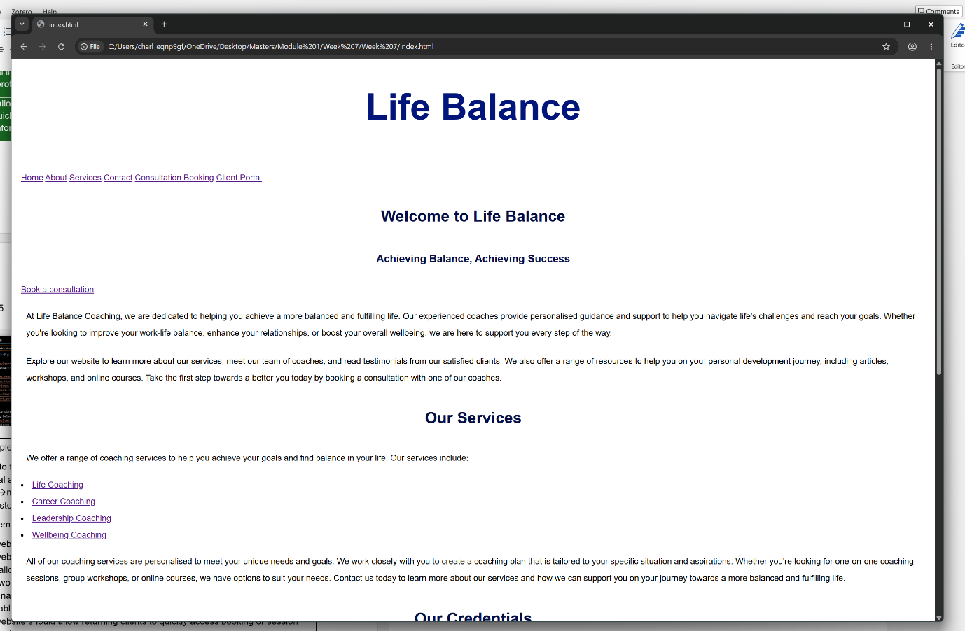
Figure 6 - CTA before making a CSS improvement in normal web browser

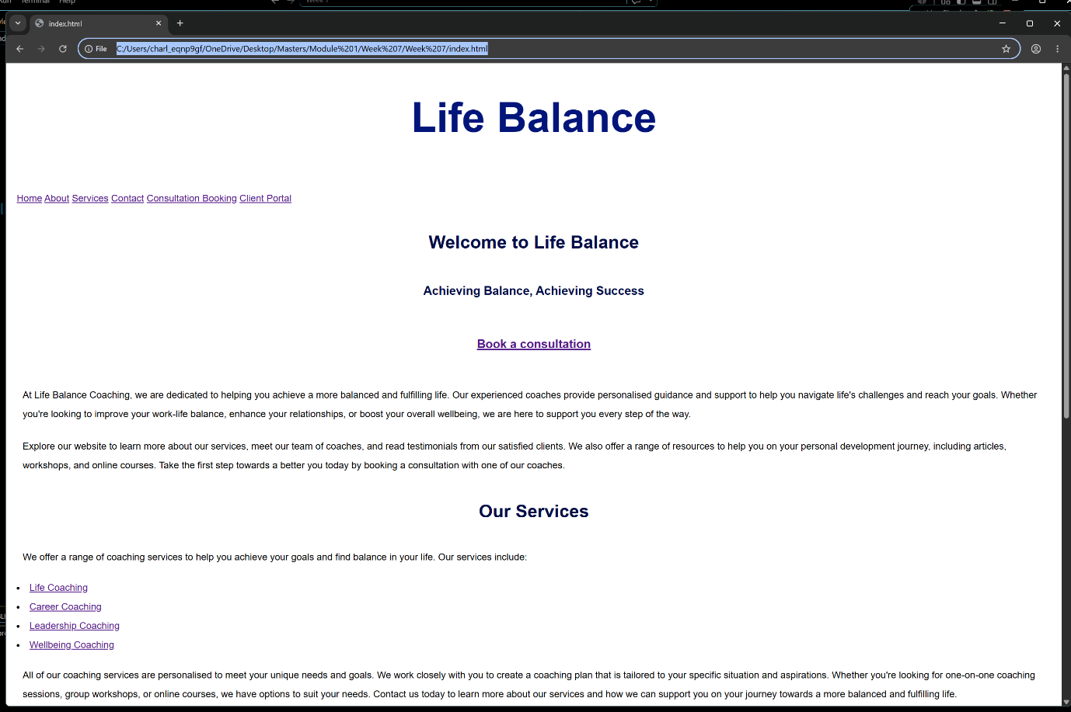
Figure 7 – CTA after making a CSS improvement in normal web browser
Figure 8 - CTA before making a CSS improvement on a narrow screen
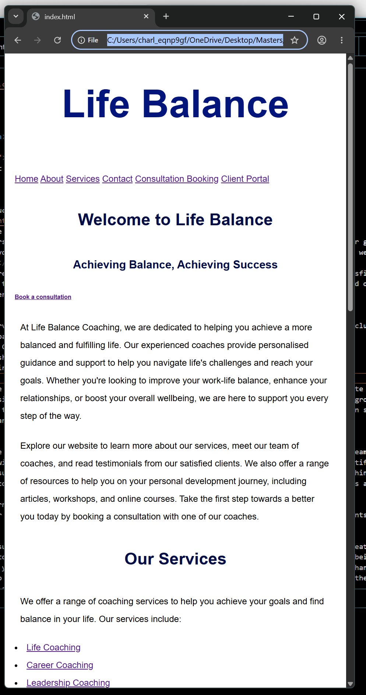

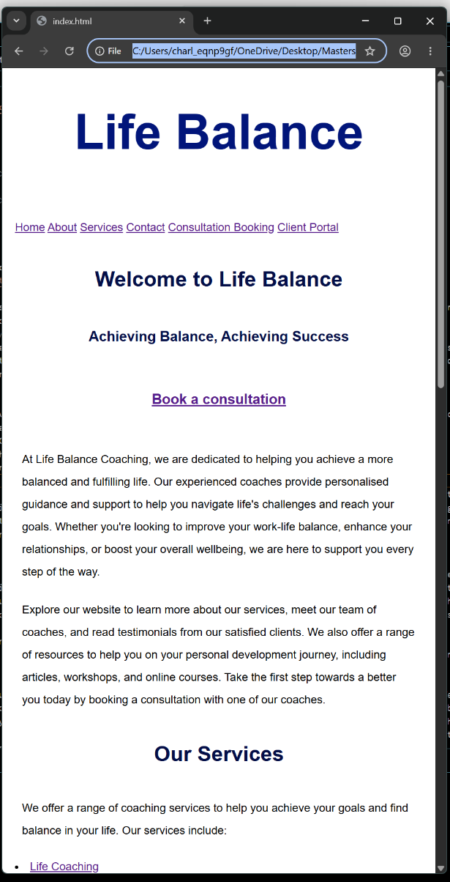
Figure 9 - CTA after making a CSS improvement on a narrow screen

I noticed that the CTA ‘Book a consultation’ could create hesitation or could be easily missed when scanning the page in both regular web browsing and on narrower screens. To combat this, I changed the CTA in CSS to a header and placed it in the centre of the page. It is now more bold and more obvious to users. It is hoped that this will also enable users to remember where this CTA is if they require it enabling more traffic to the booking page and more clients for the business. It enables more clarity and a better user experience and journey as well as being a quality decision.
- Improve heading structure and sectioning
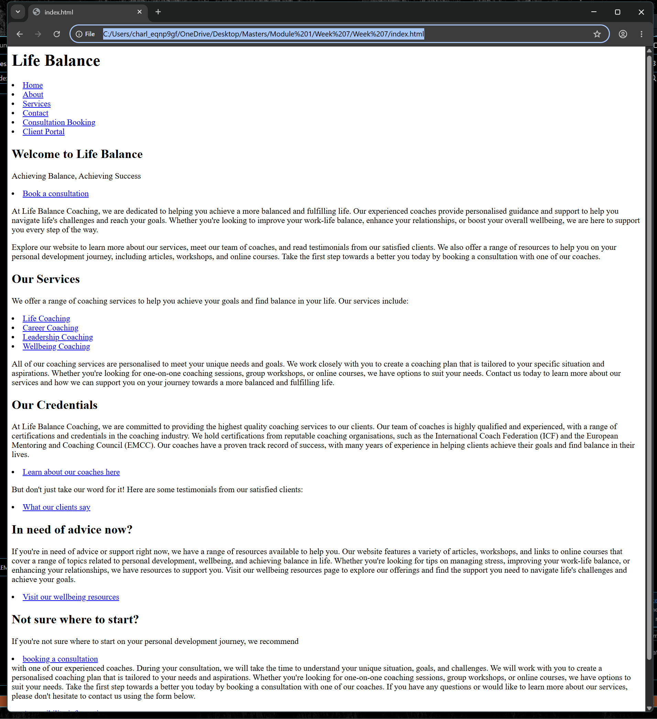
Figure 10 – Index before CSS styling

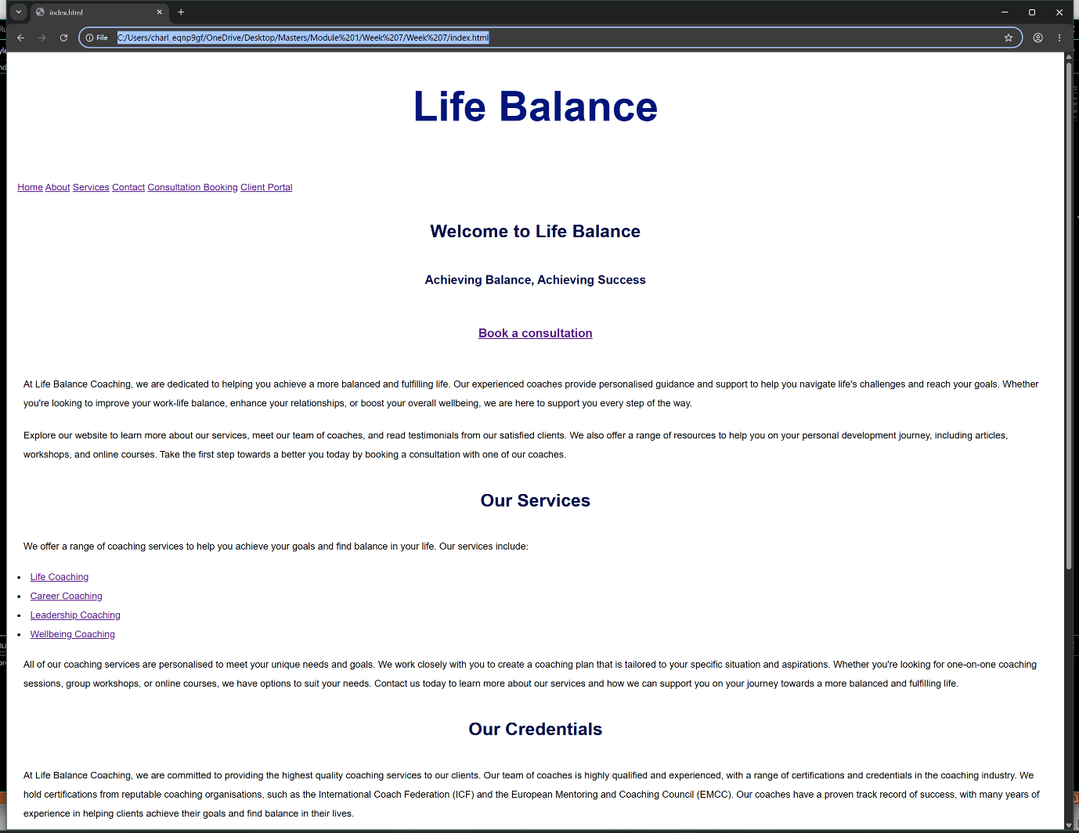
Figure 11 - Index post CSS styling
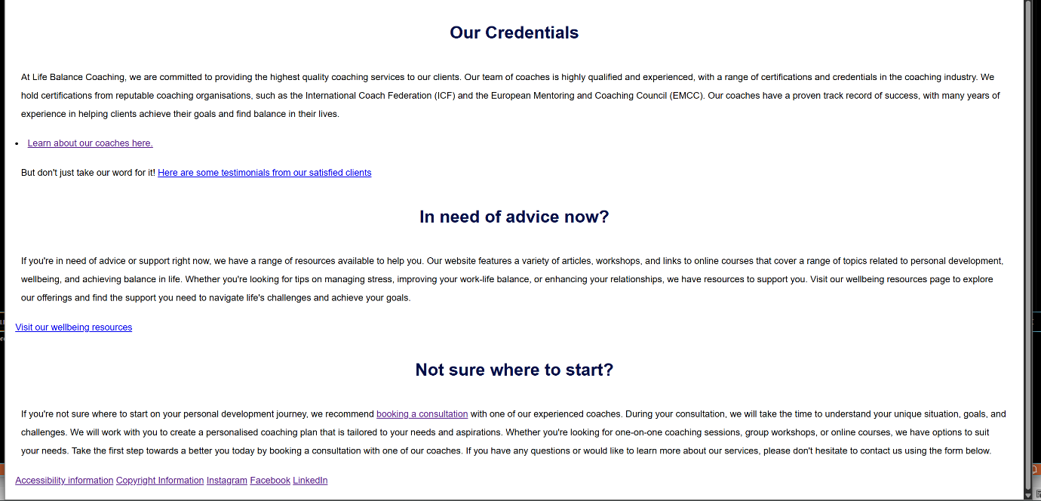
Figure 12 - Index post CSS styling cont.
The index page was particularly busy and created cognitive stress and increased cognitive load and was not very accessible or usable, especially for the visually impaired. It created confusion whilst not being well stylised and consistent in the CSS styling. To combat this I stylised the headers and sections to improve user experience and decrease cognitive load and stress for the user. The sections and headers are consistent and have hierarchy and improve accessibility awareness. The sections have greater line spacing and padding and this works well with smaller screen sizes and accessibility tools as well as working very well when the screen is zoomed >200%.

